SQL Questions- Beginner Level
Q1.
Show all customers from Mumbai.

SELECT *
FROM customers
WHERE city= 'Mumbai';

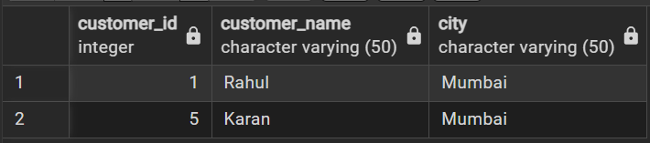

Q2.
Show all products with price greater than 10000.
SELECT *
FROM products
WHERE price > 10000;

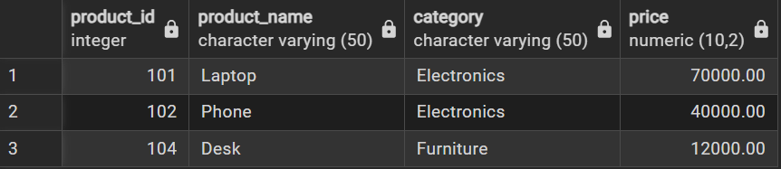

Q3.
Show all Electronics products.
SELECT *
FROM products
WHERE category ='Electronics';
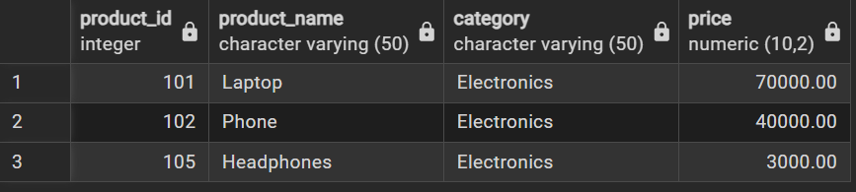

Q4.
Show orders placed after 2026-01-14.
SELECT *
FROM Orders
WHERE order_date > '2026-01-14';
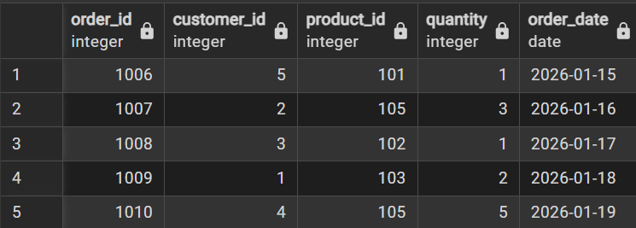

JOIN Questions
Q5.
Display customer name and order date for all orders.
SELECT c.customer_name, o.order_date
FROM customer c
INNER JOIN Oders o
ON c.customer_id = o.customer_id;
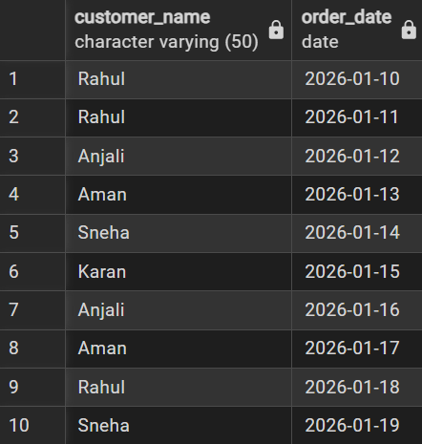

Q6.
Show customer name, product name, and quantity ordered.
SELECT c.customer_name, p.product_name, o.quantity
FROM customer c
INNER JOIN Odr o
ON c.customer_id = o.customer_id
INNER JOIN product p
ON o.product_id = p.product_id
Order by c.customer_name;

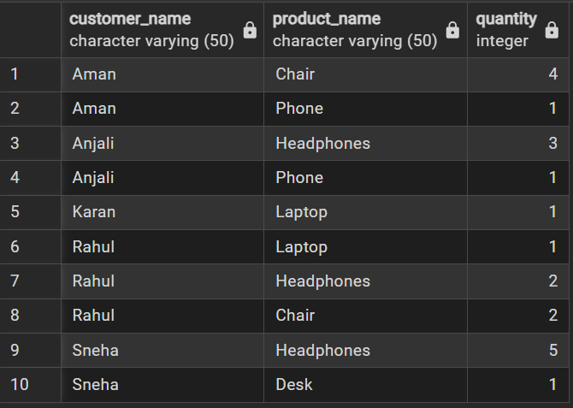

Q7.
Display all customers who purchased a Laptop.
SELECT c.customer_name,p.product_name
FROM customer c
INNER JOIN Odr o
ON c.customer_id = o.customer_id
INNER JOIN product p
On o.product_id = p.product_id
WHERE p.product_name = 'Laptop';

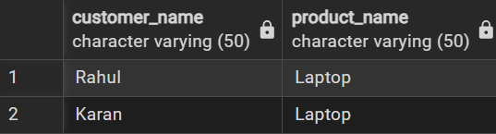

Q8.
Show total amount spent for each order.
(Hint: quantity × price)

SELECT o.order_id, (p.price* o.quantity) AS total_amount
FROM Odr o
INNER JOIN product p
ON o.product_id = p.product_id;

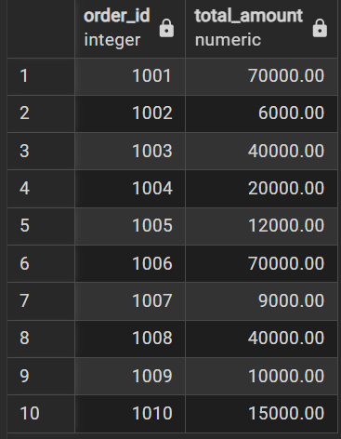

GROUP BY Questions
Q9.
Find total quantity ordered for each product.
SELECT p.product_name, SUM(o.quantity)
FROM product p
INNER JOIN Odr o
ON p.product_id = o.product_id
Group By p.product_name;

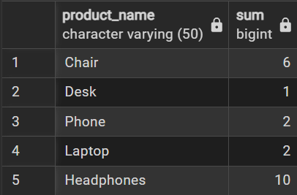

Q10.
Find total sales amount for each category.
SELECT p.category, SUM(p.price*o.quantity) AS total_sales
FROM product p
INNER JOIN Odr o
ON p.product_id = o.product_id
Group BY p.category;

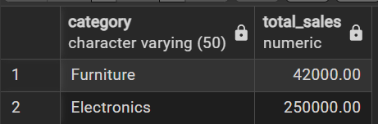

Q11.
Find total number of orders placed by each customer.
Q12.
Show average product price by category.
SELECT category,ROUND(AVG(price),2) AS average_price
FROM product
GROUP BY category;
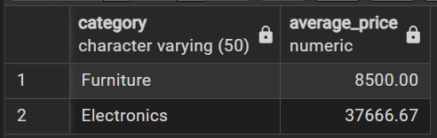
HAVING Questions
Q13.
Show categories where total sales amount is greater than 50000.
Q14.
Find customers who placed more than 2 orders.
Q15.
Show products where total quantity sold is greater than 3.
RANK / DENSE_RANK Questions
Q16.
Rank products based on price (highest first).
Use:
- RANK()
- DENSE_RANK()
Q17.
Find top 2 most expensive products.
Q18.
Rank customers based on total spending.

